Mixing Web Connection and Client Side Scripting

By Michael Hogan
http://www.id-8.com/

Last Update: September 29, 2002

Updates and Source Code
http://www.id-8.dynip.com/sessions/

Introduction

The internet is a great way of making your applications accessible to anyone in the world – and WebConnect is a great way to develop web applications at breakneck speed. Unfortunately, HTTP has a very limited user interface. If you want to be able to improve on the web paradigm or improve the performance of your web applications, Client Side Scripting is the way to do it.

What scripting options are available?
There are several scripting options available.

VBScript
VBScript can be powerful, but is limited to Internet Explorer.

Java
Java is both powerful and provides cross-browser support. Most browser require a separate, larger browser download or a plug-in to support Java. Java is a robust and complex language, and requires substantial expertise.

MacroMedia Flash Client
The Flash client can provide a graphically rich user interface. Although Flash development is geared towards a ColdFusion back end, with a little more work it can use SQL Server or XML data. The Flash client is already loaded in most browsers and may be the most common browser add-in in the universe. It’s operation is virtually identical in all browsers.

JavaScript
Javascript is supported in all modern browsers with no additional components. It is simple, object oriented, and easy to learn for the object-aware VFP developer. Working code and samples are available everywhere on the web.

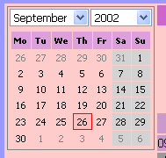
Javascript – a simple example
I needed a simple date selection control for a vertical market scheduling application. I found a free JavaScript calendar component that worked well, but it worked reliably only under Internet Explorer. I searched further and found a reliable cross-platform calendar component at www.SoftComplex.com which was available for $29 per site.

The component was easy to plug into my templates, but I needed to set the default date property of the component through VFP/WebConnect code.

Listing 1 – Javascript Calendar Control

<head>
<script language="JavaScript" src="CalendarPro/calendar.js"></script>
<!-- link here filter file for desired data format:
see comments in filter files for formats descriptions -->
<script language="JavaScript" src="CalendarPro/cal_format01.js"></script>
<!-- define the view of calendar with css rules -->
<link rel="stylesheet" href="CalendarPro/calendar.css">
</head>
<script language="JavaScript">
// parameters are:
// 1. initial date in string format of your choice - optional
// 2. form name calendar control belongs to - required
// 3. control name for date will be returned in - optional, default is datetime_<index of calendar>
// 4. minimum allowed date. if number - treated as relative number of days before date in parameter 1
// if string treated as absolute data in choosen format - optional, default - no min limit
// 5. maximum allowed date. if number - treated as relative number of days after date in parameter 1
// if string treated as absolute data in choosen format - optional, default - no min limit
// Contact the support department at support@softcomplex.com if any questions. Specify product title
// and your order ID

var cal1 = new calendar(‘<%= ldDispDate %>', 'frmWeekChart', 'calSelectedDate', null, null);

</script>

You can see in the last few lines of the code in Listing 1 how I insert the default display date for the control by simply inserting a template variable in the correct date format!
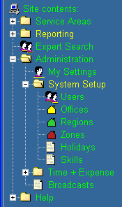

Javascript – a complex example
I needed a tree menu control for the same application. I was able to find a wonderful control at www.TreeMenu.com. The control performs quite well in all modern browsers, and is free. You can code each submenu and node by hand, or you can use one of the shareware code generators to define the submenus and nodes.

I needed to add and remove nodes based upon user access rights for security. I also needed to populate certain nodes (like personnel names and office locations) from my tables.

Note: Javascipt Object, Property and Method names MUST begin with a letter – so be careful when generating names from PK’s!

Listing 2 – JavaScript TreeMenu Control (partial listing)
Source Code Listing (Partial Listing)

<script language="JavaScript">
…
var HelpMenu = null;
HelpMenu = new MTMenu();
// MenuName.MTMAddItem(new MTMenuItem(“Menu Text", “Target",“Target Type","Tooltip",“Icon"));
HelpMenu.MTMAddItem(new MTMenuItem("What's New!", "WaNew.htm","text","Tooltip","menu_link_java.gif"));
HelpMenu.MTMAddItem(new MTMenuItem("F.A.Q.", "FAQ.htm","text","Tooltip","menu_link_help.gif"));
HelpMenu.MTMAddItem(new MTMenuItem("Overview", "Overview.htm","text","Tooltip","menu_link_help.gif"));
HelpMenu.MTMAddItem(new MTMenuItem("Scheduling Tools", "Sched.pdf","_blank","menu_link_help.gif"));
HelpMenu.MTMAddItem(new MTMenuItem("Engineer Tools", "Engineer.pdf","_blank","menu_link_help.gif"));
HelpMenu.MTMAddItem(new MTMenuItem("Admin. Tools", "Admin.pdf","_blank","menu_link_help.gif"));
HelpMenu.MTMAddItem(new MTMenuItem("About", "./main.html","text","Tooltip","menu_link_ref.gif"));
menu.items[4].MTMakeSubmenu(HelpMenu);

<%= lcAllMenus %>

</script>

In Listing 2, you can see the structure of one of the submenus as it appears in the web page. This javascript simply creates new objects and assigns values to the properties of each object. The commented line (preceded by “//”) illustrates the use of each parameter.

To create a new TreeMenu node, you first create a new MTMenu() object. You then call the MTMAddItem() method for each node, using the correct parameters. You finally define the submenu’s position in the “menu” tree with menu.items[4].MTMakeSubmenu(menuname).

In order to add nodes and submenus, we simply need to generate the same string structure in a VFP variable and insert it into the HTML page using ExpandTemplate() – just like we did in the simple example. The only difference here is in the complexity of the text string.

You can see in the next to last line of code how we have inserted the VFP variable. The VFP code used to insert the administration menu for users above a certain access level is shown in Listing 4

Listing 3 – Populating the TreeMenu Control (partial listing - VFP)
Source Code Listing (Partial Listing)

IF loUserInfo.Accesslevl>2
lcAllMenus=lcAllMenus+;
[// nested submenu - Setups] + CR + [var SetupMenu = null;] + CR +;
[SetupMenu = new MTMenu();] + CR +;
[SetupMenu.MTMAddItem(new MTMenuItem("Users", "Users.ges","text","Edit Users","persons.gif"));]+CR+;
[SetupMenu.MTMAddItem(new MTMenuItem("Offices", "Off.ges","text","Edit Offices","yell.gif"));]+CR+;
[SetupMenu.MTMAddItem(new MTMenuItem("Regions", "Reg.ges","text","Edit Regions","green.gif"));]+CR+;
[ReportMenu.MTMAddItem(new MTMenuItem("Week", "WkAll.ges","text","Wk Sched","gear.gif"));] + CR+;
[ReportMenu.MTMAddItem(new MTMenuItem("Month", "MthAll.ges","text","Mth Sched","gear.gif"));] + CR+;
[ReportMenu.MTMAddItem(new MTMenuItem("Quarter", "QrAll.ges","text","Q Sched","gear.gif"));] + CR+;
"AdminMenu.items[1].MTMakeSubmenu(SetupMenu);" + CR
ENDIF

The specific string generated will vary from tool to tool – but this methodology will work for any Javascript code that uses parameters and properties to define its behavior.

You can see how easy it would be to generate tree nodes from tables by generating a text string similar to the above within as SCAN loop.

Javascript – WC free selective display
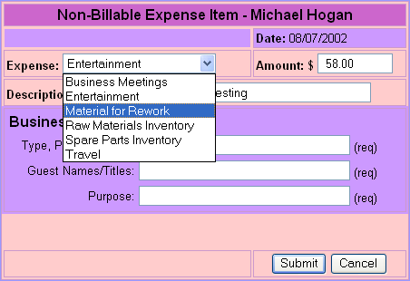
Within the same application, I needed the user to fill in different fields depending upon a combobox selection. I didn’t want to hit my WV application to display a different page each time the combobox was changed – it was too slow and generated unnecessary hits on the back-end.

I needed to add and remove nodes based upon user access rights for security. I also needed to populate certain nodes (like personnel names and office locations) from my tables.

I found a simple example on one of the many javascript sites on the Internet, and adapted it to my application. It simply toggles the visibility of cells within the table, based upon the combobox selection.

Listing 4 – Toggle Visibility in Javascript
Source Code Listing (Partial Listing)

<script language="JavaScript"> <!--
function hideShow(which) {
var laContainer = new Array();
laContainer[0] = "SYS_3641";
laContainer[1] = "SYS_3640";
section = eval("document."+which) ;
lcelementid = (which) ;
if (document.layers) {
document.SYS_3641.visibility = 'hide' ;
document.SYS_4640.visibility = 'hide' ;
section.visibility = hide ? 'hide' : 'show' ;
}
else {
for(count=0 ; count < 2 ; count++) {
section = eval("document.all."+laContainer[count]) ;
var g = document.all ? section :
document.getElementById(laContainer[count]);
g.style.visibility = (laContainer[count]==lcelementid) ? 'visible' : 'hidden';
}
}
}
//--> </script>
<style type="text/css">
body,td,p,li,dd,dt,ul,dl,ol,a {
font-family: Arial, sans-serif;color:black;
}
.hideable {position: relative; visibility: hidden; }
</style>
</head>
<body ONLOAD="hideShow(frmJobSchedule.SelCategory.value)">

Listing 4 illustrates the Javascript code that toggles visibility. When called with a parameter, this code will turn off visibility of objects with the IDs SYS_3641 and SYS_3640, and then turn on the object with the ID that matches the parameter.

The combo box has an ID of ‘SelCategory’, and we want to make sure the visibility of the fields is correct when first entering the form – so in the ONLOAD of the form (see the last line of code) we call the hideShow function with the default value of the combobox.

The .hideable style definition simply prevents the cells from displaying and flashing off when the form is loaded by making them start out hidden.

NOTE: JavaScript objects, properties and methods are CASE SENSITIVE!

We identify the ID of the rows to be toggled with the following HTML code:

Listing 5 – Toggle Visibility in Javascript – Define row IDs
Source Code Listing (Partial Listing)

<tr bgcolor="#CC99FF" ID="SYS_3640" CLASS="hideable">
<td><font size="-1">Mileage - Personal Car
<input type="text" name="PersMilage" size="4" maxlength="4" value="<%= lcPersMilage %> ">
miles</font></td>
<td width="141">
<div align="center"><font size="-1">Value of Mileage will be calculated
for you</font></div>
</td>
</tr>

We then re-set the visibility of the rows in question based upon the selected ComboBox value with the following code snippet:

Listing 6 – Toggle Visibility in Javascript – Combo OnChange
Source Code Listing (Partial Listing)

<td><font size="-1"><b>Expense:</b>
<select name="SelCategory" ONCHANGE="hideShow(this.value);">
<%= lcCategoryPulldown %>
</select>
</font></td>

The contents of the combobox in this case is generated in VFP with ExpandTemplate()
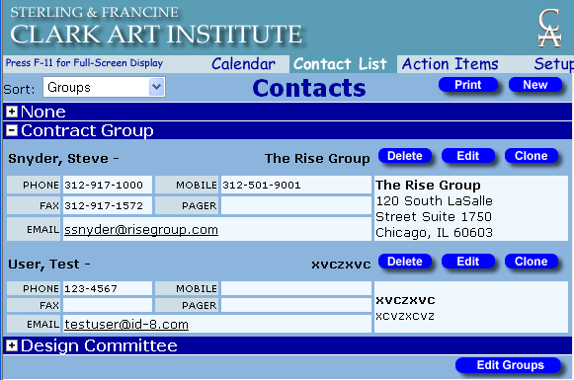

Javascript – Advanced Selective Cell Display
I wanted to use expand buttons to display a contact list in groups. I needed to generate the table in VFP code, but I wanted to toggle the row visibility when the plus or minus sign was clicked in Javascript to eliminate unnecessary and slow round-trips to the server.

Browsers handle row visibility differently. IE closes the row to a height of zero when it is made invisible. Many other browsers make the row contents invisible, but the space taken up by the row remains. This script was written to work only in IE, and to simply display all contents expanded in other browsers. Since this client wanted an IE only application, this was acceptable behavior in this case.

To accomplish this, we have the toggle function written in Javascript within the header of the template file:

Listing 7 – Toggle Visibility– Javascript Toggle Function
Source Code Listing (Partial Listing)

<script language="JavaScript">
<!--
ie4 = ((navigator.appName == "Microsoft Internet Explorer") &&
(parseInt(navigator.appVersion) >= 4 ));

function toggle( myId, myImage ){
if (ie4){
thisId=document.all(myId);
thisImage=document.all(myImage);
if (thisId.style.display ==
"none"){
thisId.style.display =
"";
thisImage.src="Images/Minus.gif";}
else {
thisId.style.display =
"none";
thisImage.src="Images/Plus.gif";
}
}
}
</script>

The code in listing 7 is called when the plus/minus is clicked. It swaps the image and toggles the visibility of the specified row. Listing 8 illustrates the VFP code used to generate the table contents:

Listing 8 – Toggle Visibility– VFP Table Generation
Source Code Listing (Partial Listing)

SCAN
IF ISNULL(GroupCode)
lcGroupCode = "DummyText"
lcGroupDescript = "None"
ELSE
lcGroupCode = GroupCode
lcGroupDescript = GroupDescript
ENDIF
IF lcGroupCode != lcLastGroup && NEW GROUP STARTING!
lcLastGroup = lcGroupCode
*Open new row with plus sign:
lcContactTable=lcContactTable+[ <tr bgcolor="#00009C">] + CR +;
[ <td width="38%" align="center" class="todaytext" colspan="2">] + CR +;
[ <div align="left" onclick="toggle('R]+lcGroupCode+[','I]+lcGroupCode+[')">]+;
[<img src="Images/Plus.gif" width="18" height="18" name="I]+lcGroupCode+;
[" align="absmiddle"></font><b><font color="#FFFFFF">] + lcGroupDescript +;
[</font></b></div>] + CR +;
[ </td>] + CR +;
[ </tr>] + CR +;
[ <tr bgcolor="#8CB5DE">] + CR +;
[ <td width="38%" align="center" colspan="2" id="R]+lcGroupCode+;
[" style="display='none'">] + CR
ENDIF
lcContactTable=lcContactTable+[ <table border="2" cellspacing="1" width="100%" height="6px" class="daylist" bgcolor="#8CB5DE" bordercolor="#8CB5DE">] + CR
lcContactTable=lcContactTable… [ </table>] + CR
ENDSCAN

Since each row to be toggled and each image to be swapped needs a unique ID, I generate them programmatically from the PK’s. Javascript requires that object ID’s begin with a letter. Since my PK might begin with a number, I prepend an R (for rows) or an I (for images) to the PK to create the object ID.

Notice the ‘onclick’ method of each image, which passes the row ID and the image ID to the ‘toggle’ function.

Conclusion

The use of client side scripting opens up the restrictive world of HTML controls to create a more friendly user interface, increases the apparent speed of your applications, and reduces server load by avoiding unnecessary roundtrips to your WC applications. Controlling them with VFP and WC is as simple as template expansion.

Resources

Updates and Source Code
http://www.id-8.dynip.com/sessions/

